Assignment – 5

- Windows System Information:
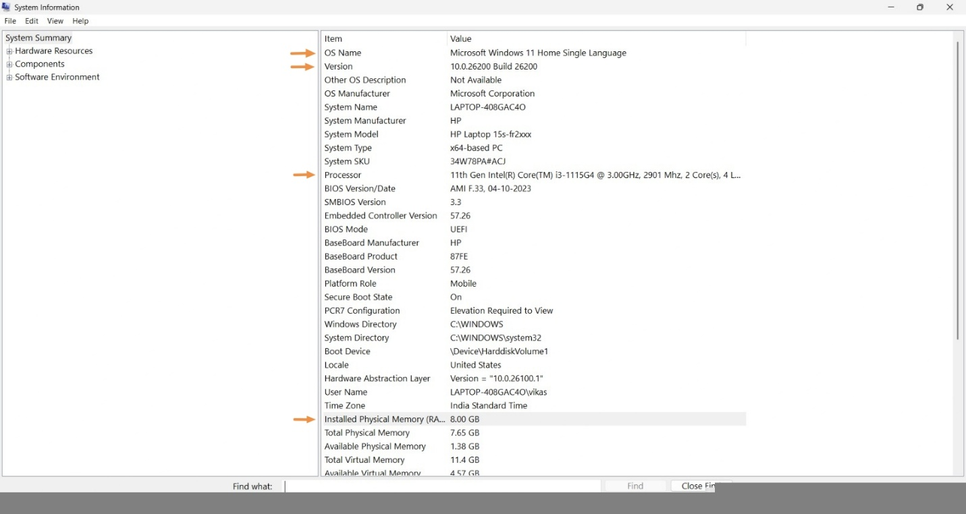
- Change Desktop Wallpaper and System Language in Windows 11:
Steps:
- Open Settings by pressing Windows + I.
- Go to Personalization → Background.
- Under Personalize your background, select Picture.
- Choose any picture to change the desktop wallpaper.
- Go back to Settings → Time & language → Language & region.
- Click Add a language.
- Search for Hindi or Gujarati.
- Select the language and click Next → Install.
- Under Windows display language, select Hindi or Gujarati.
- Sign out and sign in again to apply the language change.
Result:
The desktop wallpaper was changed successfully, and the Windows display language was changed to Hindi/Gujarati.
5. Windows 10 Installation Guide:
Step-by-step guide to install Windows 10:
- Backup all important files.
- Create a bootable Windows 10 USB.
- Restart the laptop and boot from USB.
- Select language, keyboard, and click Install Now.
- Enter the product key or skip it if applicable.
- Select Custom Installation.
- Select the correct partition carefully and install Windows.
- Complete the Windows setup and create a user account.
- Install required drivers.
- Run Windows Update.
- Review Privacy settings and disable unwanted options.
- Install necessary applications and security updates.
The steps were mostly clear. However, the exact boot-menu key and required drivers depend on the laptop model. Partition selection also needs extra care to avoid data loss.

